Assignment 5（Writeup）



Created By:

Group: Chengyin Liu(cl93), Ran Jin(Oliver)(rj23)

Mar 30, 2018

COMP 540 – Statistical Machine Learning

Rice University

Problem 1)

1. In neural networks, the number of parameters controls the size of the hypothesis space. Thus, more parameters are structured if there exist more hidden layers. We know that a shallow network has less hidden layers than a deep network has. Thus, deep network would have the model learn more detailed relationships within the data and how the features interact with each other on a non-linear basis.

(Reference: https://stats.stackexchange.com/questions/222883/why-are-neural-networks-becoming-deeper-but-not-wider)

1. The concept of leaky ReLU is a way to eliminate the dying ReLU problem. Essentially, a leaky ReLU is written as:

$$f(x)=\left\{\begin{aligned}x, x>0 \\ αx,x≤0\end{aligned}\right.$$

A leaky ReLU is when x $≤$ 0, instead of having the function going to zero(This is what regular ReLU function does), will it have the function to be some small slope α(e.g 0.05 or so).

(Reference: https://ayearofai.com/rohan-4-the-vanishing-gradient-problem-ec68f76ffb9b)

|  |  |  |  |  |
| --- | --- | --- | --- | --- |
|  | AlexNet | VGG-Net | GoogleNet | ResNet |
| Years introduced | 2012 | 2014 | 2015 | 2015 |
| Number of layers | 8 | 19 | 22 | 152 |
| Data Augmentation | Yes | Yes | Yes | Yes |
| Inception(NIN) | No | No | Yes | No |
| Dropout | Yes | Yes | Yes | Yes |
| Top 5 error | 16.4% | 7.3% | 6.7% | 3.57% |
| Convolutional layers | 5 | 16 | 21 | 151 |
| Size of fully connected layers | 4096,4096,1000 | 4096,4096,1000 | 1000 | 1000 |

Overall, we see that as newer networks were introduced, the number of layers and convolutional layers have increased which is the defining characteristic for each network. And we see that as number of layers and convolutional layers increase, the top 5 error has decreased from 16.4% to 3.57%.

Problem 2)

$H(S)=H(\frac{p}{p+n})=\frac{p}{p+n}log_{2}(\frac{p+n}{p})\frac{n}{p+n}log_{2}(\frac{p+n}{n})$

$$≤log_{2}(\frac{p}{p+n}⋅\frac{p+n}{p}+\frac{n}{p+n}⋅\frac{p+n}{n})=log_{2}(2)=1$$

Finally, when $n=p$, we have $H(S)=\frac{1}{2}log_{2}(2)+\frac{1}{2}log_{2}(2)=1$

b)

$$Misclassification A:\frac{100+100}{400+400}=\frac{1}{4}$$

$$Misclassification B: (200)/(400+400)=1/4$$

$$Entropy A: H(D)=-\frac{1}{2}log(\frac{1}{2})-\frac{1}{2}log(\frac{1}{2})=1$$

$$H(D_{1})=\frac{-1}{4}log(\frac{1}{4})-\frac{1}{4}log(\frac{1}{4})=0.811$$

$$H(D_{2})=\frac{-1}{4}log(\frac{1}{4})-\frac{1}{4}log(\frac{1}{4})=0.811$$

Thus, entropy gain for A: $1-\frac{1}{2}*0.811-\frac{1}{2}*0.811=0.189$

$$Entropy B: H(D)=1$$

$$H(D_{1})=\frac{-1}{3}log(\frac{1}{3})-\frac{2}{3}log(\frac{2}{3})=0.918$$

$$H\left(D_{2}\right)=-log⁡(-1)=0$$

Thus, entropy gain for B: $1-\frac{3}{4}*0.918=0.3115>0.189$, thus, model B is the preferred split.

Gini Index A: $G\left(D_{1}\right)=2*\frac{1}{4}*\frac{3}{4}=\frac{3}{8}$, $G\left(D_{2}\right)=2*\frac{1}{4}*\frac{3}{4}=\frac{3}{8}$, thus gini index for A is

$$\frac{1}{2}-\frac{1}{2}*\frac{3}{8}+\frac{1}{2}*\frac{3}{8}=\frac{1}{8}$$

Gini Index B: $G\left(D_{1}\right)=2*\frac{1}{3}*\frac{2}{3}=\frac{4}{9}$, $G\left(D_{2}\right)=0$, thus gini index for B is

$$\frac{1}{2}-\frac{3}{4}*\frac{4}{9}+\frac{1}{4}*0=\frac{1}{6}>\frac{1}{8}$$

Thus, model B is the preferred split.

c)

The misclassification rate will not increase when splitting a feature.

Suppose there exists a parent node P with C children, where each of them has $a_{i} positive examples, and b_{i} negative examples and i=1,…, C$.

Then we have the error rate for parent $E_{P}$ and children $E_{C}$:

$$E_{P}=\frac{min⁡(\sum_{i=1}^{C}{a_{i}, \sum_{i=1}^{C}{b_{i} }})}{\sum_{i=1}^{C}{{(a}_{i}+b_{i}) }}, E_{C}=\frac{\sum_{i=1}^{C}{min⁡(a_{i},b_{i})}}{\sum_{i=1}^{C}{{(a}_{i}+b_{i}) }}$$

Since the denominators are the same, now we want to show that the nominator for children is less than or equal to the nominator for parent in order to show that $E_{P} ≥E_{C}$ always holds which is an indication such that the misclassification rate will not increase when splitting a feature.

We know that $min⁡(a_{i},b_{i})$ $≤ a_{i}$, $min⁡(a_{i},b_{i})$ $≤b_{i}$,

then $min⁡(\sum_{i=1}^{C}{a_{i}, \sum_{i=1}^{C}{b_{i} }})$ $≤ \sum_{i=1}^{C}{a_{i} }$, $min⁡(\sum_{i=1}^{C}{a_{i}, \sum_{i=1}^{C}{b_{i} }})≤ \sum_{i=1}^{C}{b_{i} }$,

then we say that $\min\left(\sum_{i=1}^{C}{a_{i}, \sum_{i=1}^{C}{b_{i} }}\right)≤\sum_{i=1}^{C}{min⁡(a_{i},b_{i})}$ which is what we desired to show and that concludes that the misclassification rate will not increase when splitting a feature.

Problem 3)

$E_{bag}=E_{X}\left[{ε_{bag}\left(x\right)}^{2}\right]=E_{X}\left[{\left(\left(\frac{1}{L}\sum_{l=1}^{L}{\left(f\left(x\right)+ε_{l}\left(x\right)\right)}\right)-f\left(x\right)\right)}^{2}\right]$

$$=E_{X}\left[{\left(\frac{1}{L}\sum_{l=1}^{L}{\left(ε_{l}\left(x\right)\right)}\right)}^{2}\right]=\frac{1}{L^{2}}E_{X}\left[{\left(\sum_{l=1}^{L}{\left(ε_{l}\left(x\right)\right)}\right)}^{2}\right]=\frac{1}{L^{2}}E_{X}\left[\sum_{l=1}^{L}{{ε_{l}}^{2}\left(x\right)}+\sum_{1<i,j<L (i≠j)}{ε_{i}\left(x\right)ε_{j}\left(x\right)}\right]=\frac{1}{L^{2}}E_{X}\left(\sum_{l=1}^{L}{{ε_{l}}^{2}\left(x\right)}\right)+\frac{1}{L^{2}}E_{X}\left(\sum_{1<i,j<L \left(i≠j\right)}{ε_{i}\left(x\right)ϵ_{j}\left(x\right)}\right)=\frac{1}{L^{2}}\sum_{l=1}^{L}{E_{X}({ε_{l}}^{2}\left(x\right))}+\frac{1}{L^{2}}\sum_{1<i,j<L \left(i≠j\right)}{E_{X}(ε_{i}\left(x\right)ε_{j}\left(x\right))}=\frac{1}{L^{2}}\sum_{l=1}^{L}{E_{X}({ε_{l}}^{2}\left(x\right))}=\frac{1}{L}E_{av}$$

1. Since $E_{bag}=(\frac{1}{L})^{2}E_{X}[(\sum_{l=1}^{L}{ε_{l}}(x))^{2}]$,

Then $(\sum_{l=1}^{L}{\frac{1}{L}}ε_{l}(x))^{2}≤\sum_{l=1}^{L}{(}\frac{1}{L}ε_{l}(x)^{2})$ by Jeason’s inequity,

Then $E_{X}[(\sum_{l=1}^{L}{\frac{1}{L}}ε_{l}(x))^{2}]≤E_{X}[\sum_{l=1}^{L}{(}\frac{1}{L}ε_{l}(x)^{2})]=\sum_{l=1}^{L}{E_{X}}[(\frac{1}{L}ε_{l}(x)^{2})]=E_{av}$

Problem 4)

Problem 4.1.1: Affine layer: forward

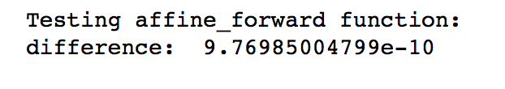

Problem 4.1.2: Affine layer: backward

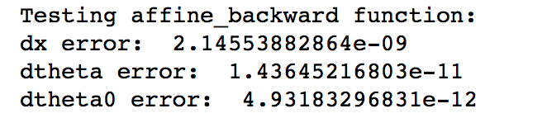

Problem 4.1.3: ReLU layer: forward

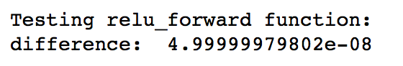

Problem 4.1.4: ReLU layer: backward

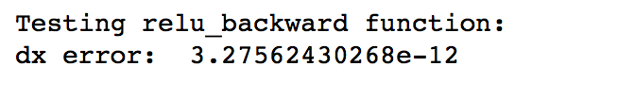

Sandwich layers

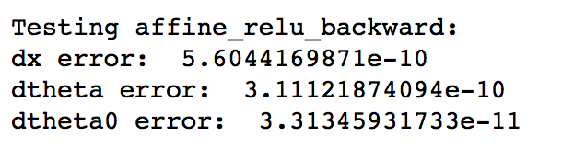

Loss layers: softmax and SVM

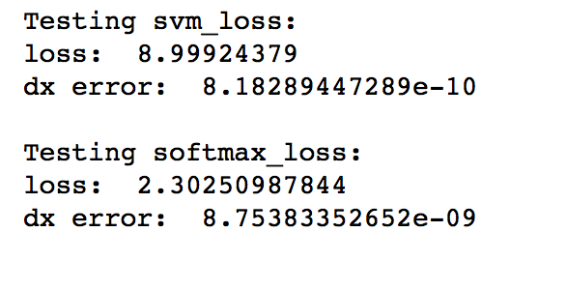

Problem 4.1.5: Two layer network

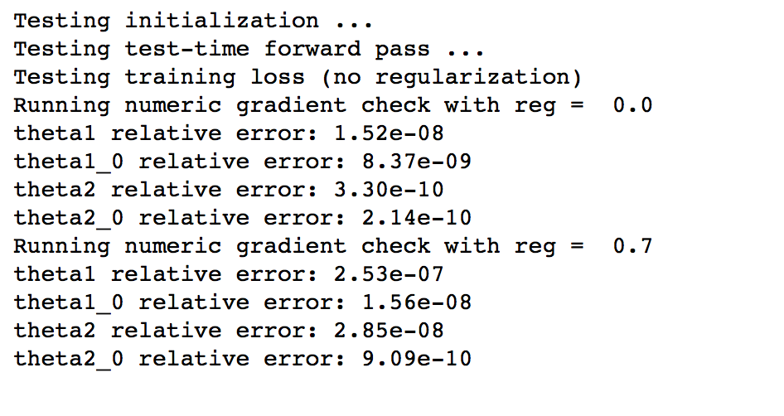

Problem 4.1.6: Overfitting a two layer network

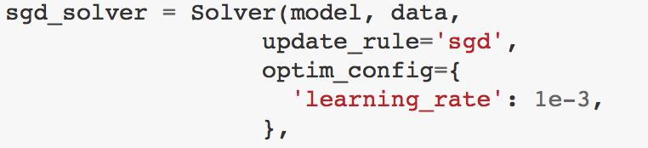

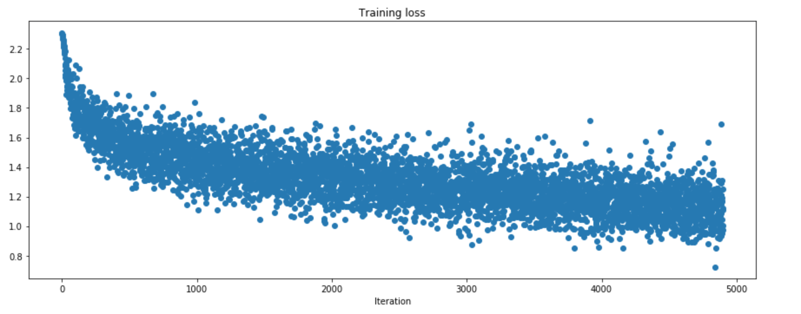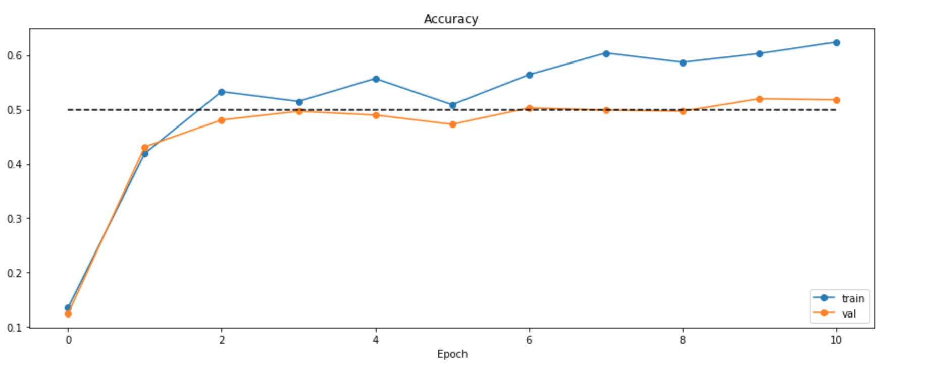

Problem 4.1.7: Multilayer network

Yes, the initial loss is around lnC = 2.303, where C=10.

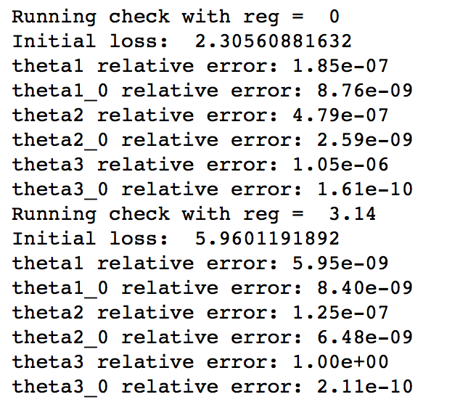

Problem 4.1.8: Overfitting a three layer network

weight_scale = 1e-2, learning_rate = 1e-2

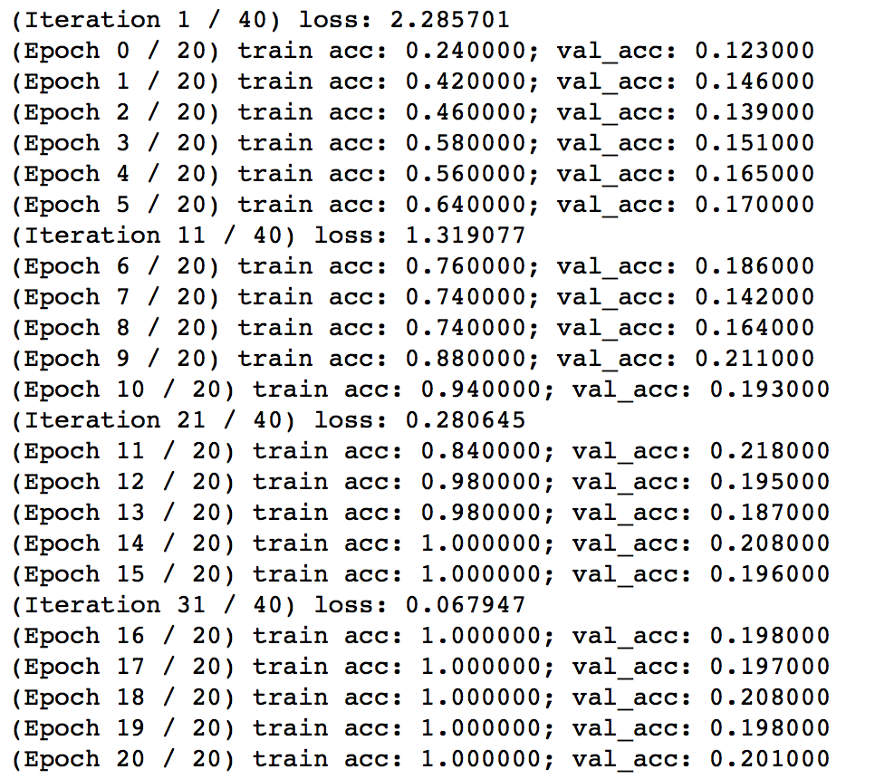

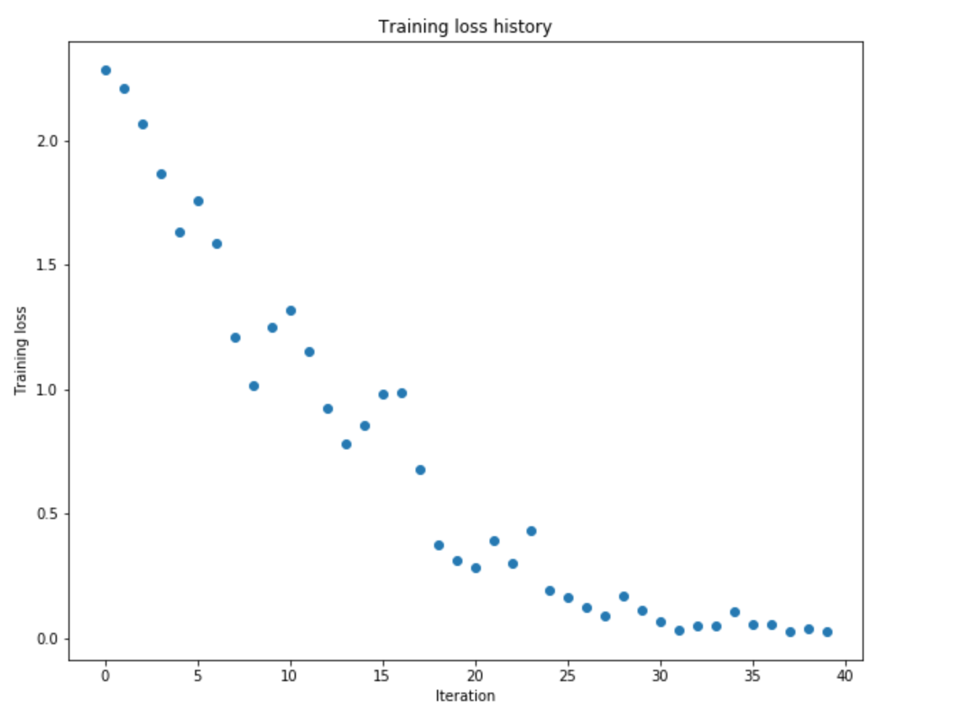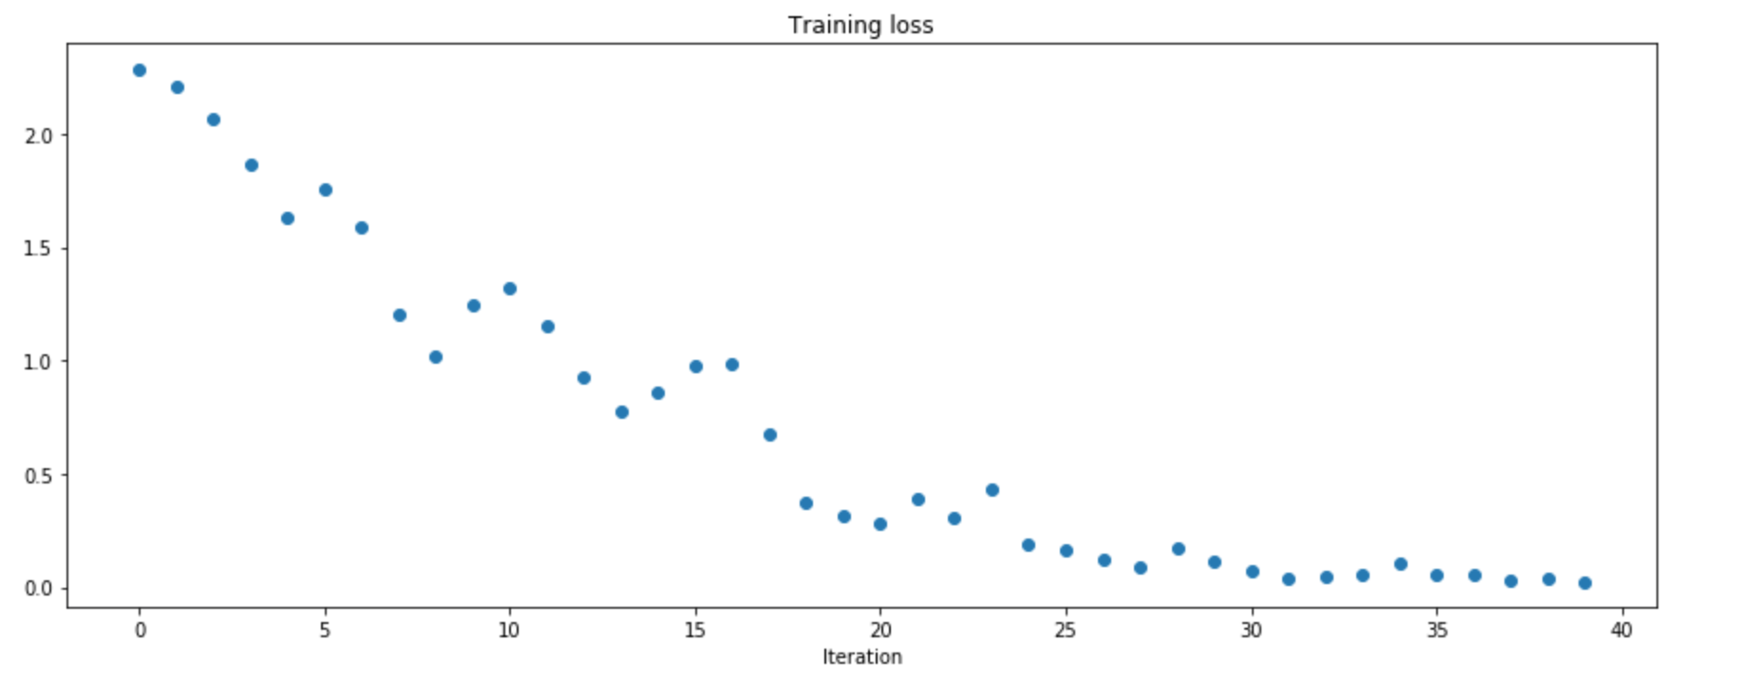

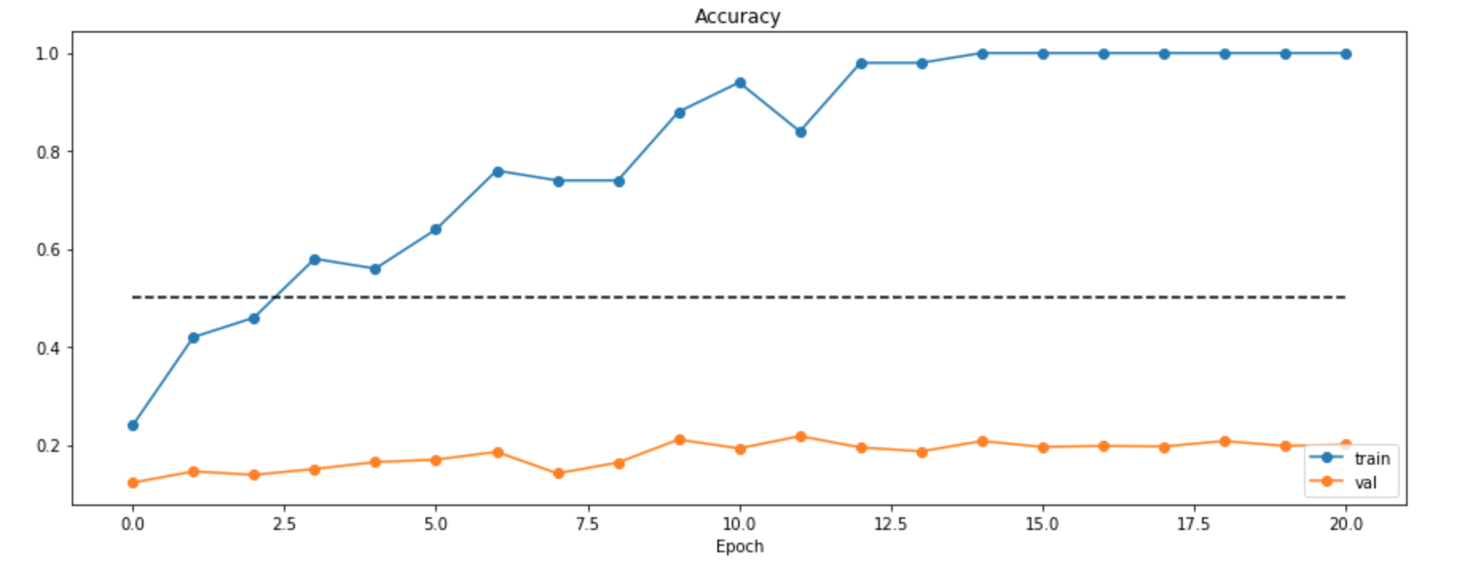

Problem 4.1.9: Overfitting a five layer network

learning_rate = 1e-2, weight_scale = 5e-2

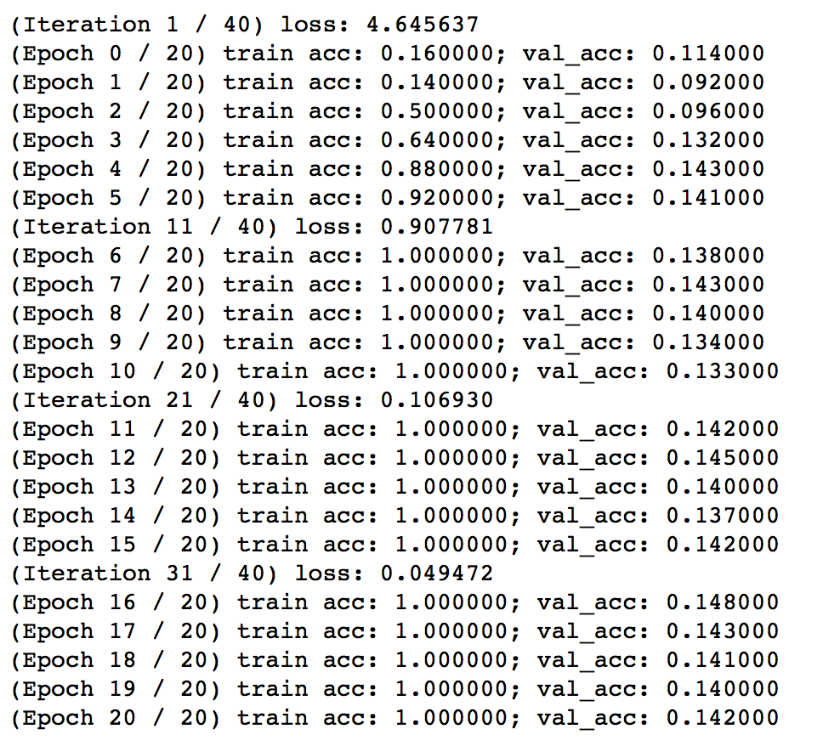

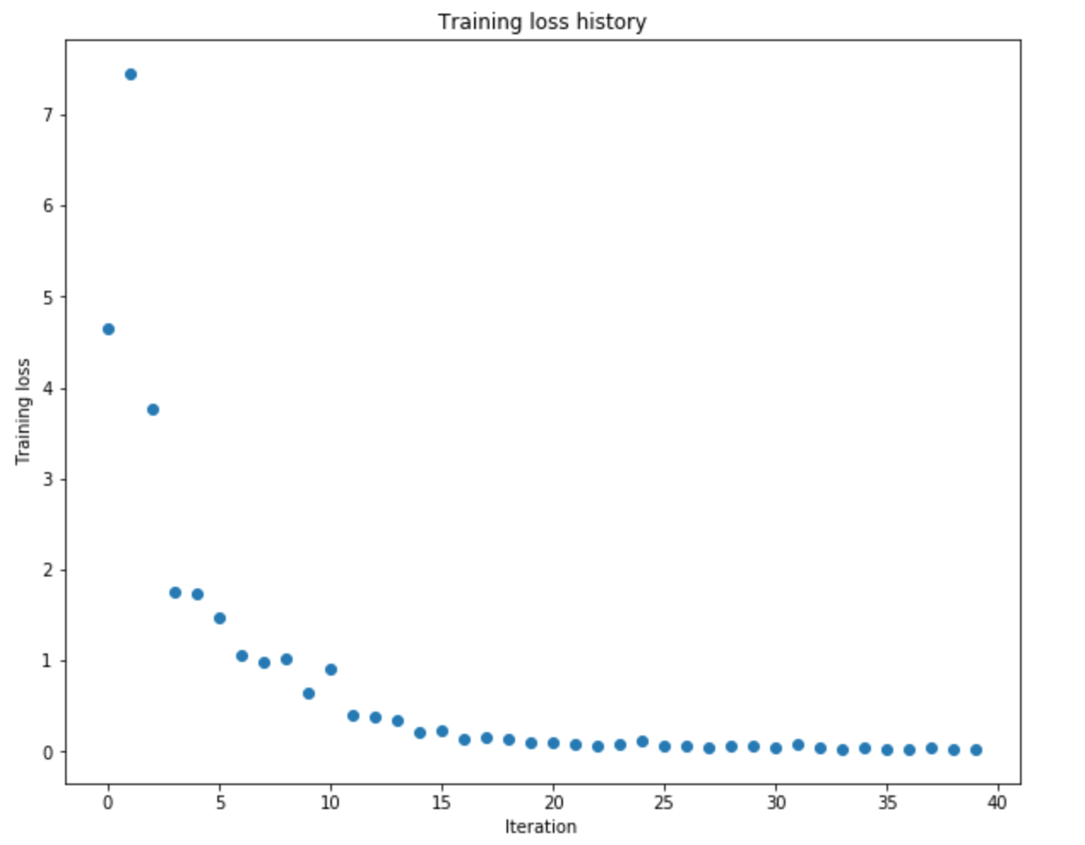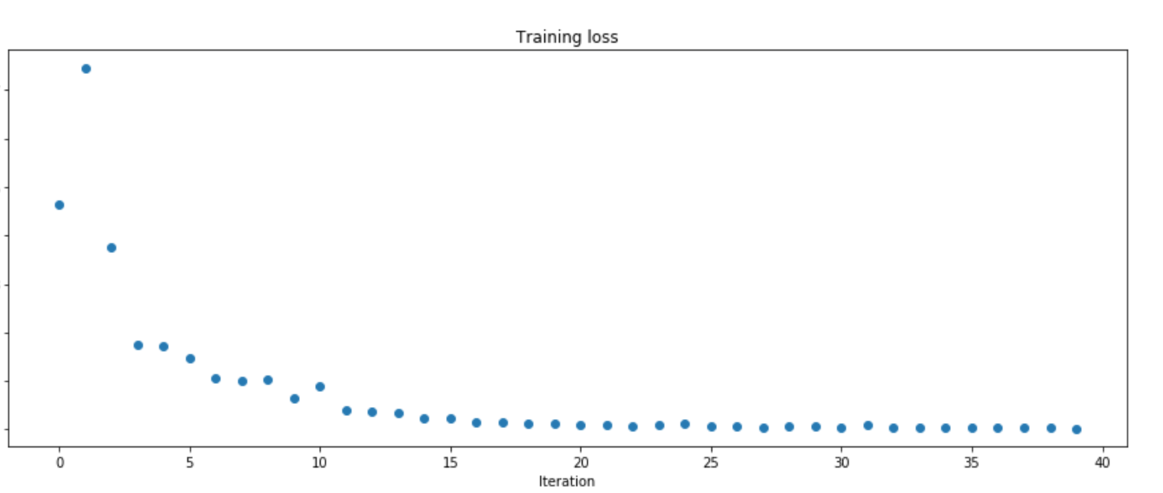

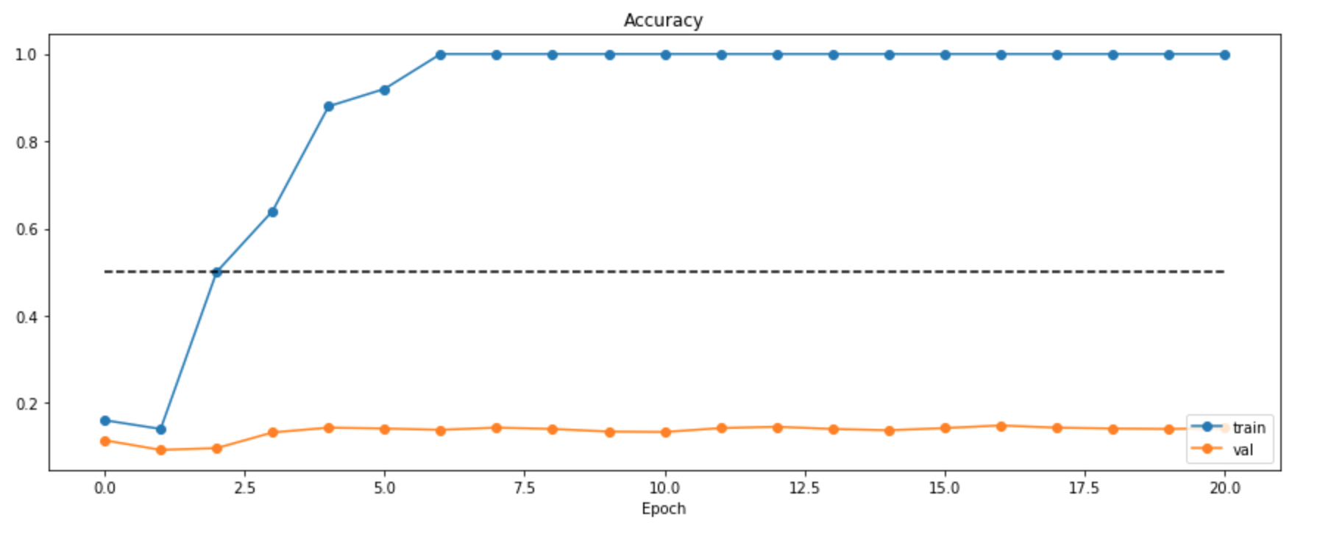

Overall, with the parameters that we have selected shown above, we did not notice that if one runs faster than the other.

Problem 4.1.10: SGD+Momentum

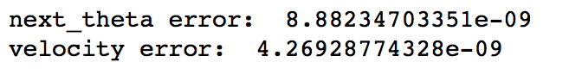

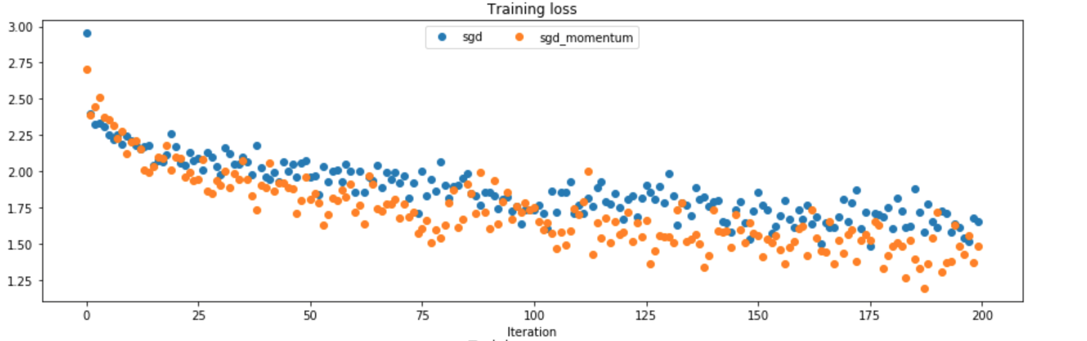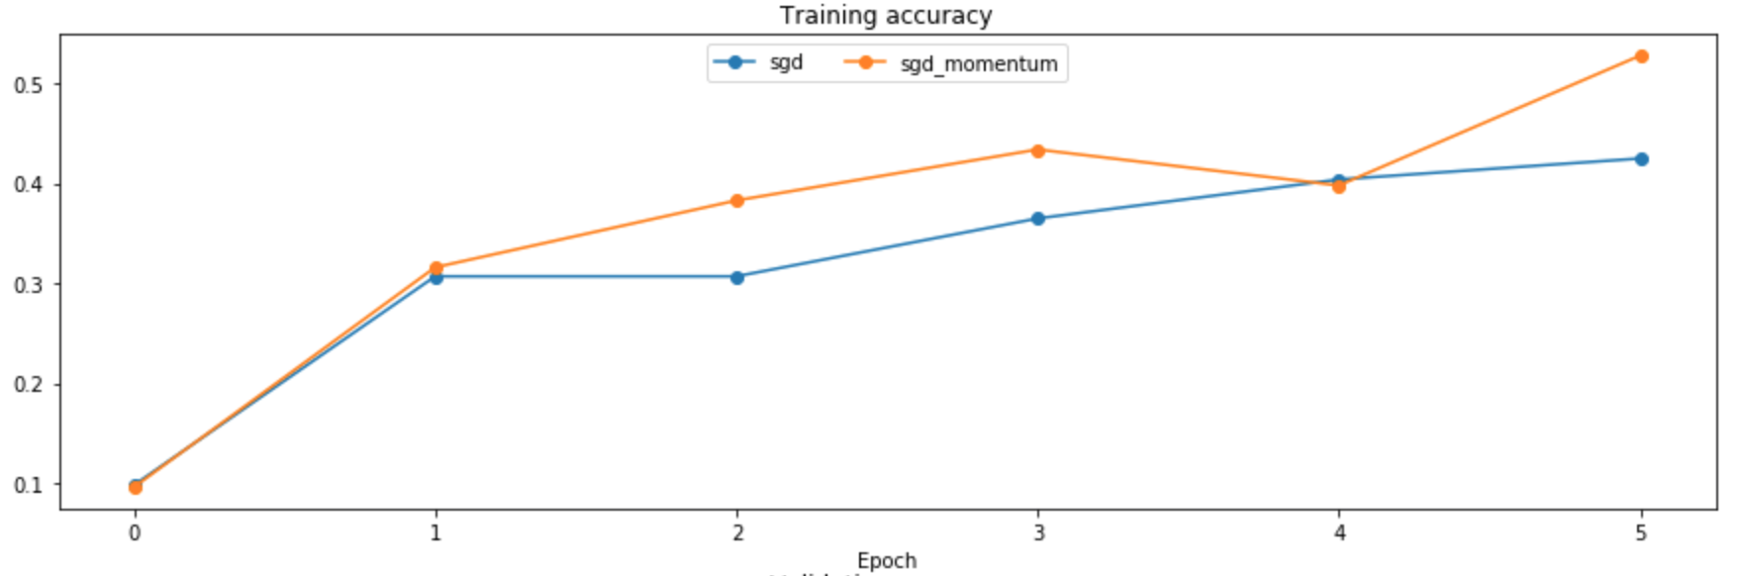

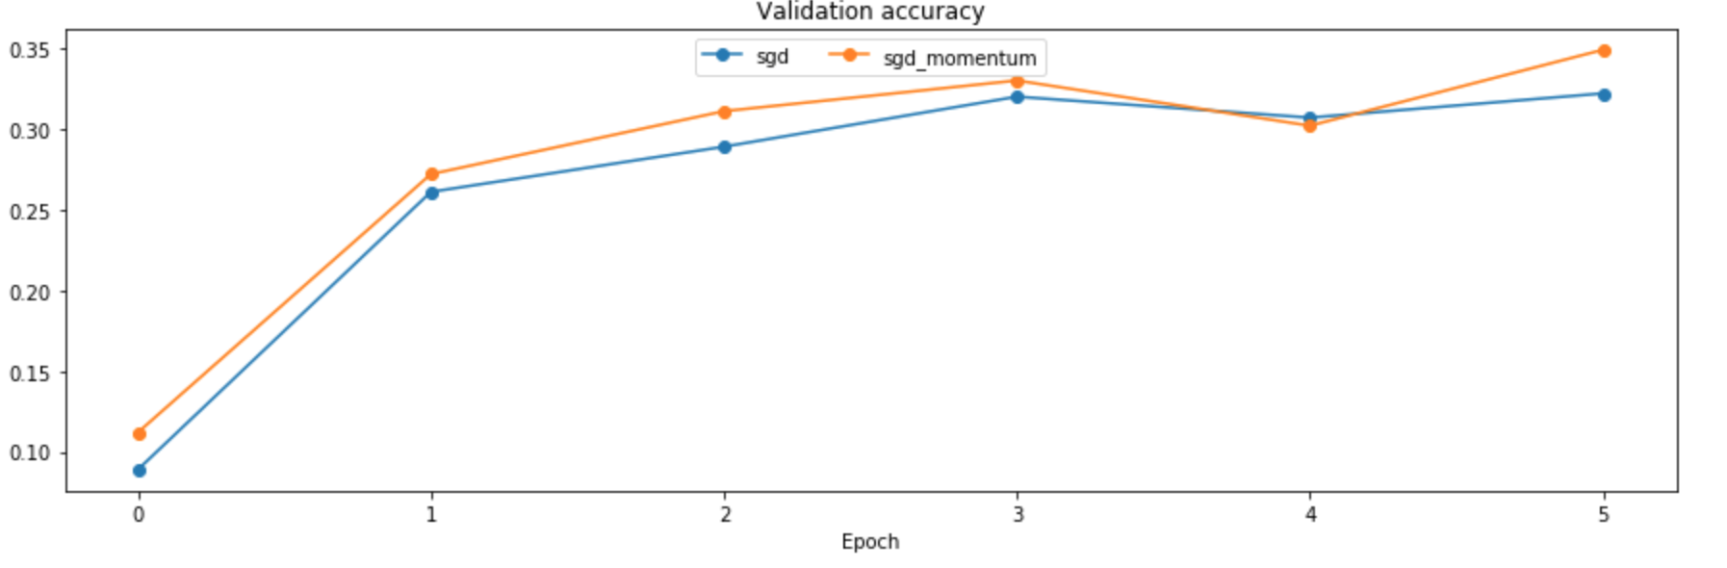

Problem 4.1.11: RMSProp

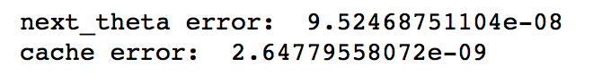

Problem 4.1.12: Adam

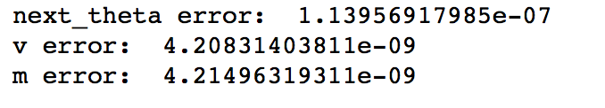

Problem 4.1.13: Comparison between different model

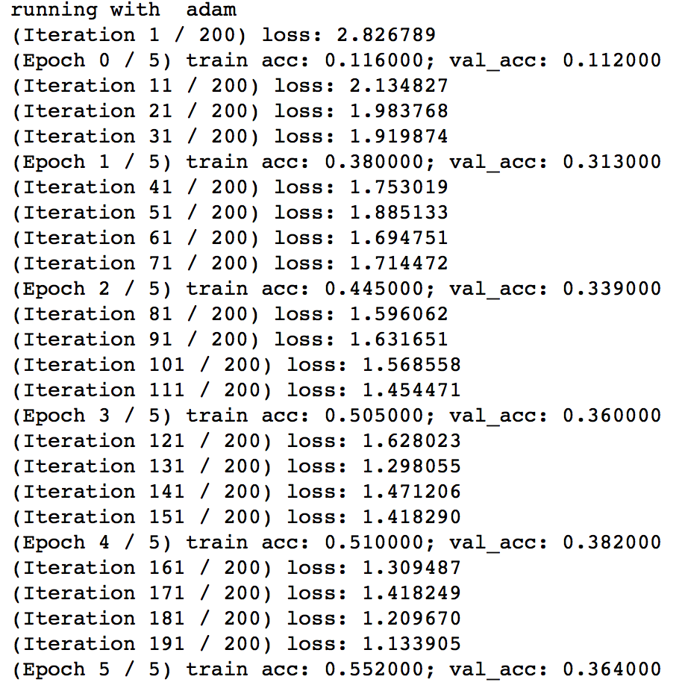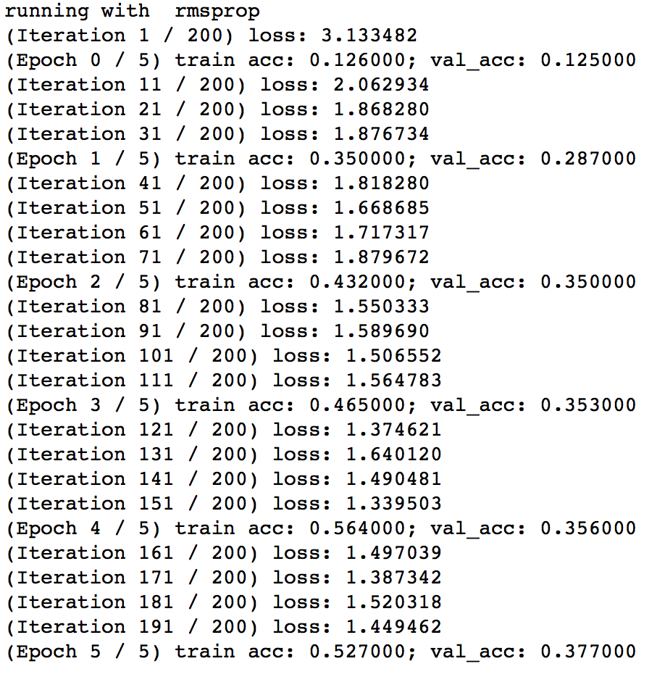

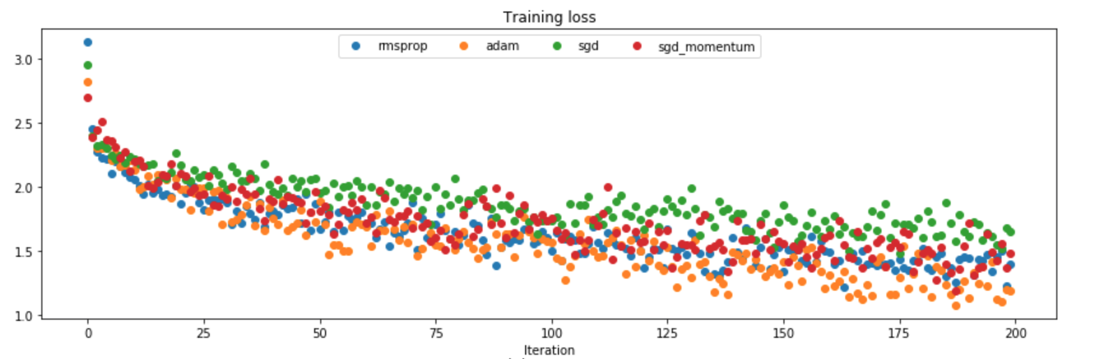

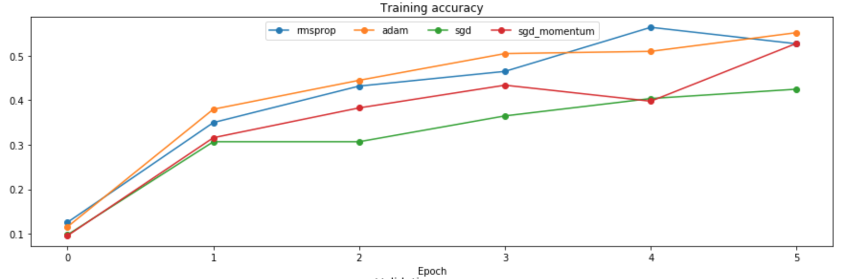

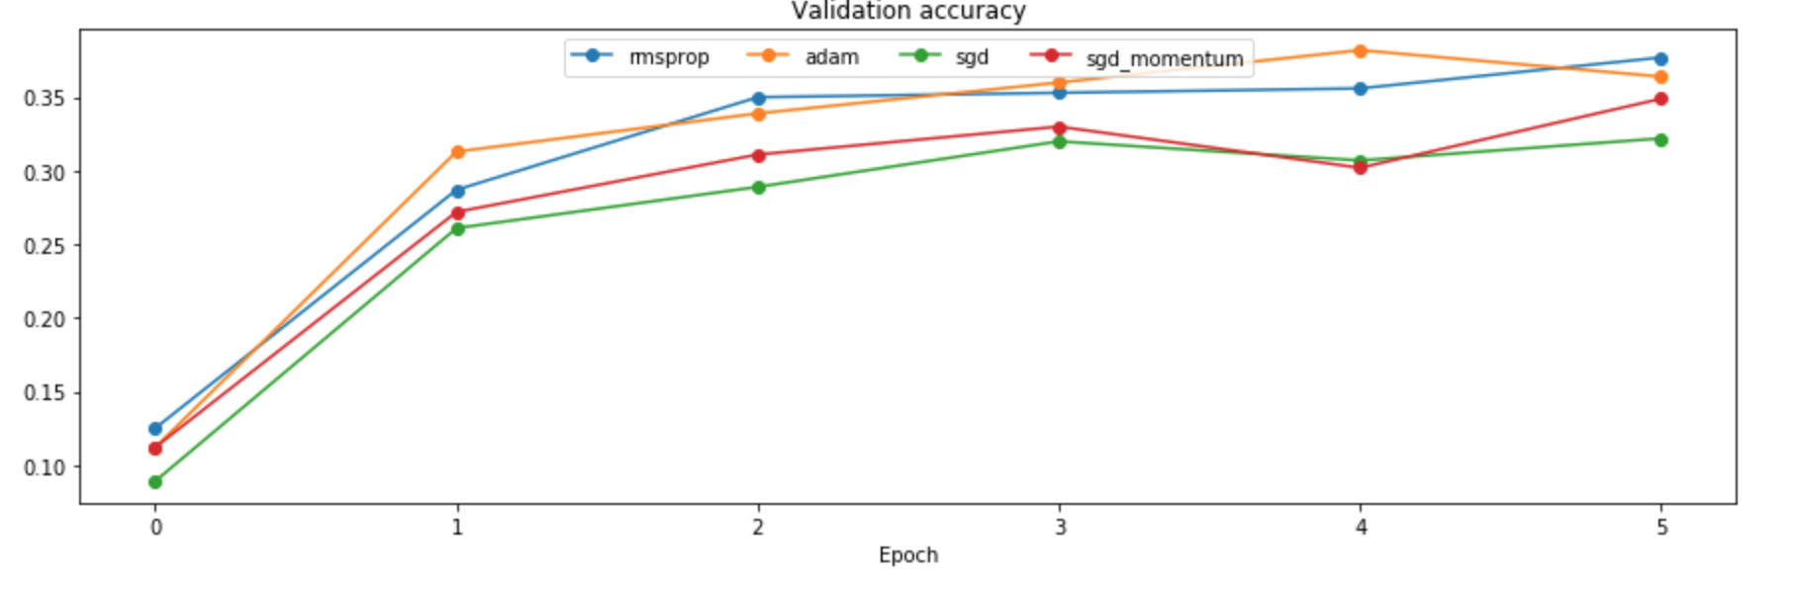

Problem 4.2.1: Dropout forward pass

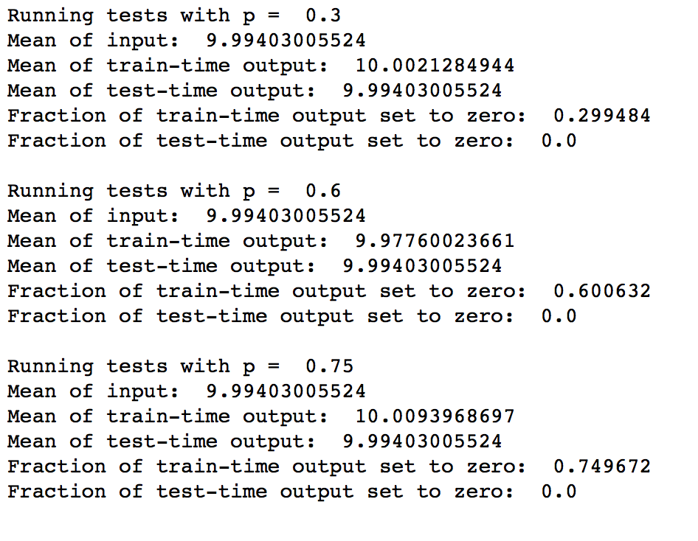

Problem 4.2.2: Dropout backward pass

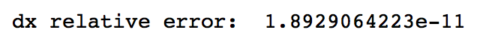

Problem 4.2.3: Fully connected nets with dropout

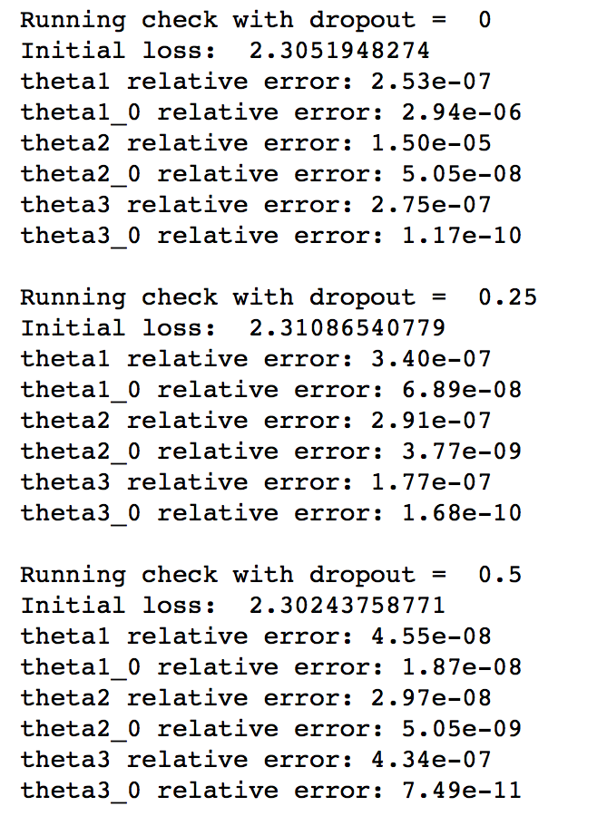

Problem 4.2.4: Experimenting with fully connected nets with dropout

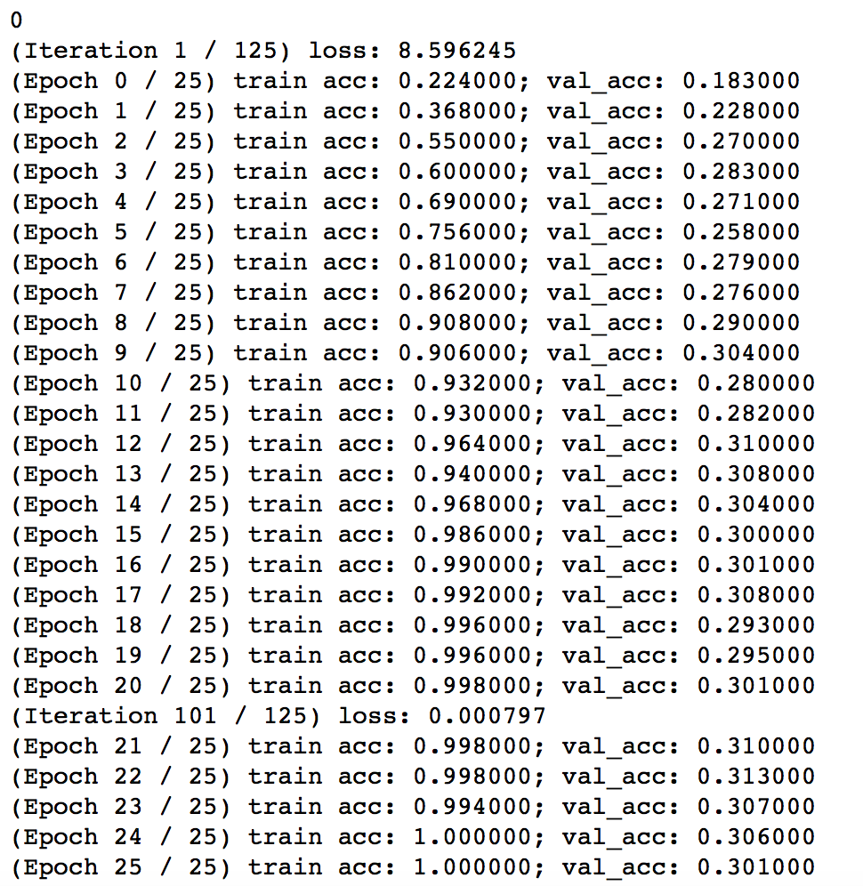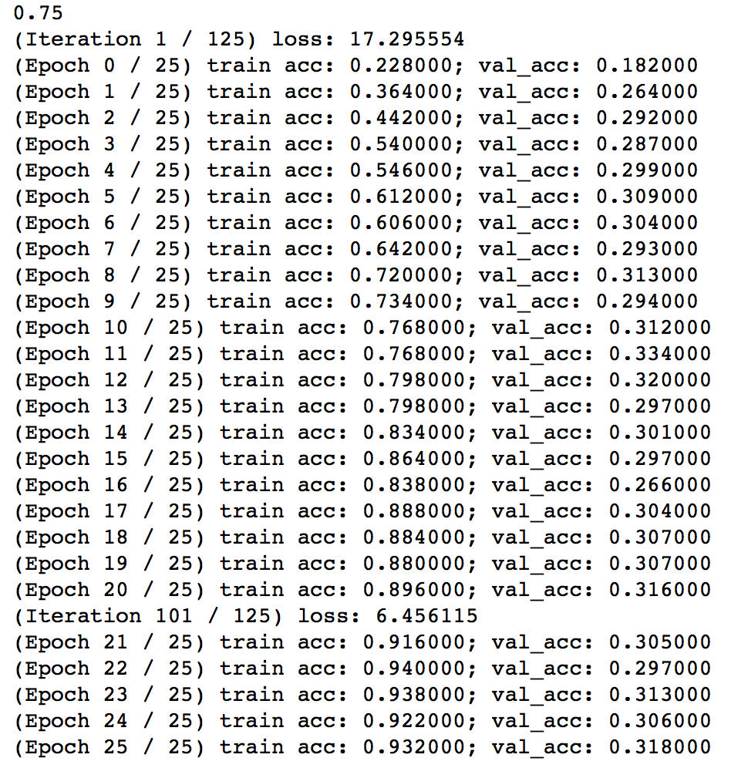

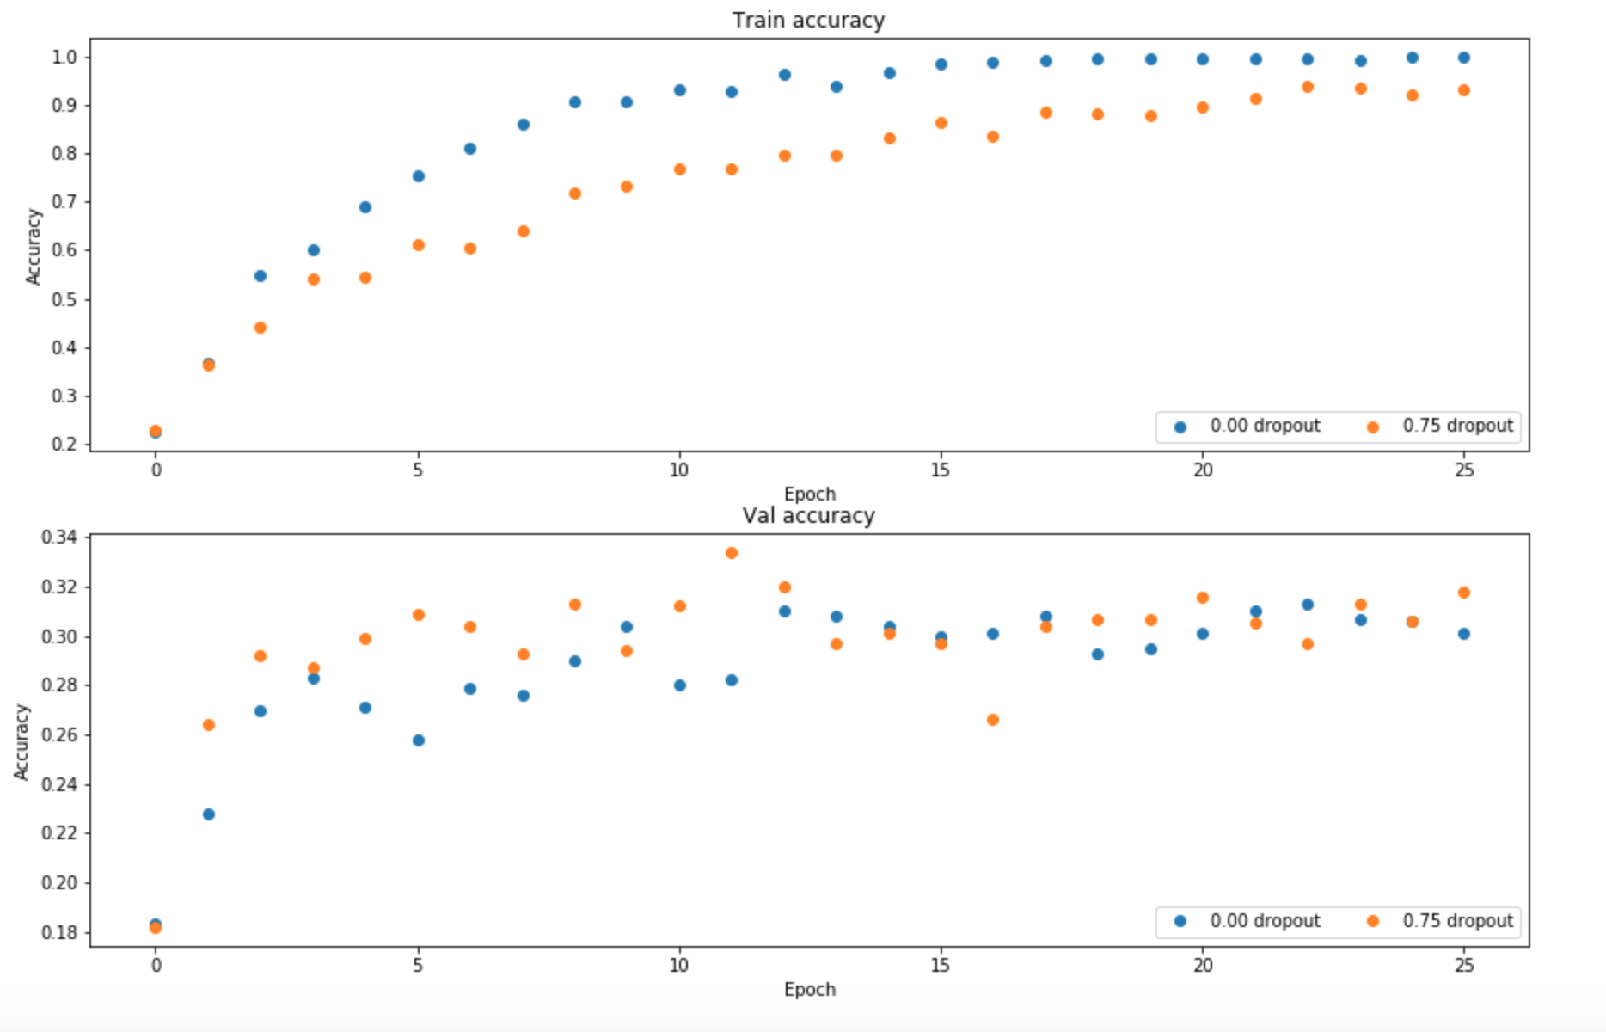

From the graph above, we see that the network with dropout converge much faster. And we also see that the shapes of curves for validation and training with dropout seem to be less volatile (less variance) than the ones without dropout. The model without dropout tends to over-fit the dataset, thus performs better on training set. Therefore, the graph shows that the model without dropout has better training accuracy, but its validation accuracy is lower than the model with dropout. However, the network with dropout is a better fit for the real model. Thus, it has a higher validation accuracy.

Problem 4.3: Training a fully connected network for the CIFAR-10 dataset with dropout

With parameters selected as below,

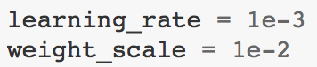

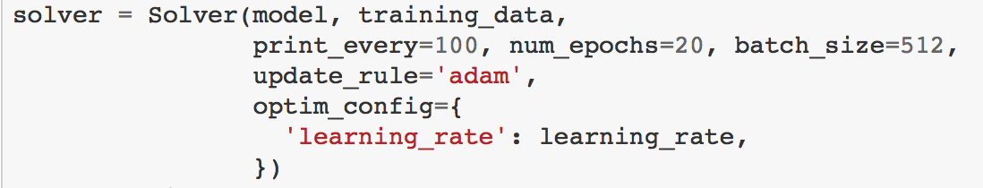

We get

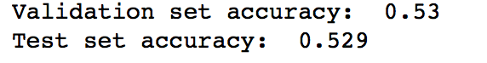

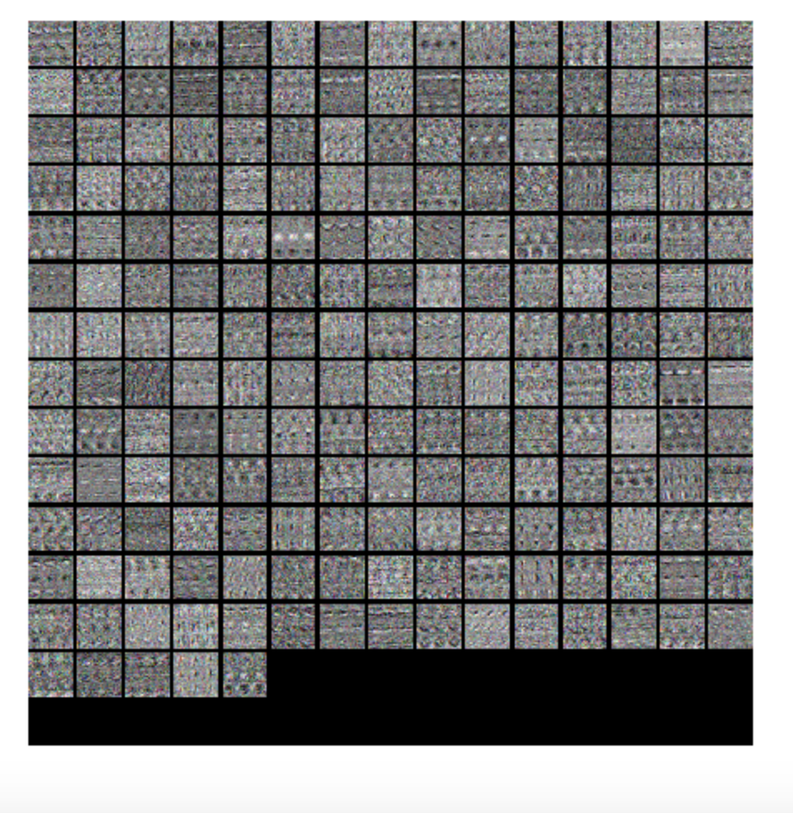

Problem 4.4.1: Convolution: naive forward pass

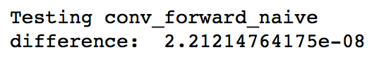

Problem 4.4.2: Convolution: naive backward pass

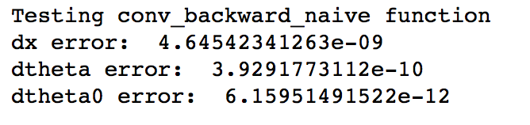

Problem 4.4.3: Max pooling: naive forward pass

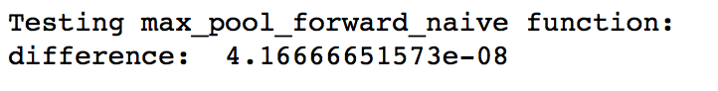

Problem 4.4.4: Max pooling: naive backward pass

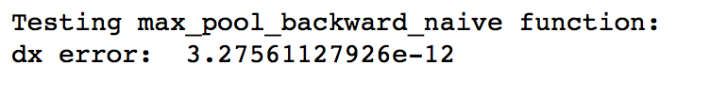

Fast layers

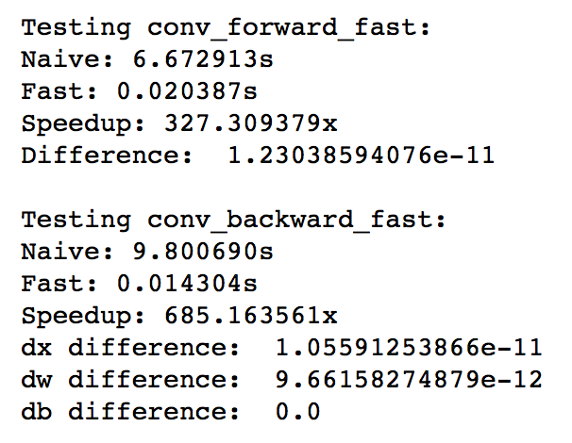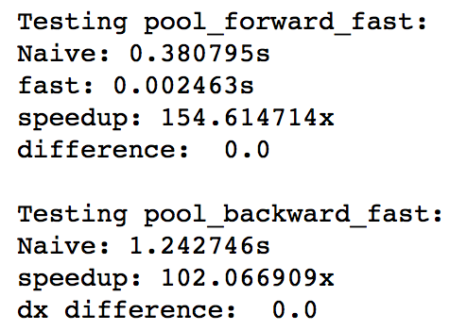

Convolutional sandwich layers

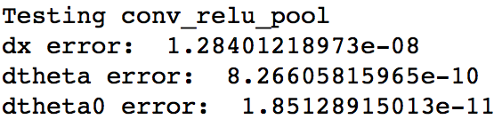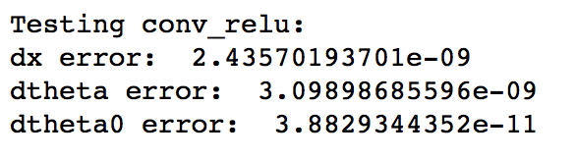

Problem 4.4.5: Three layer convolutional neural network

Loss computation:

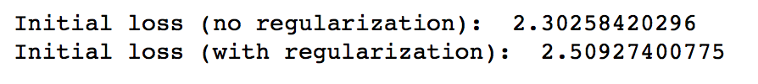

Gradient Check:

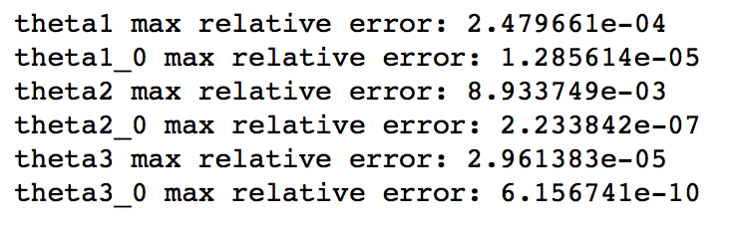

Overfit small data:

With the following being the parameters selected,

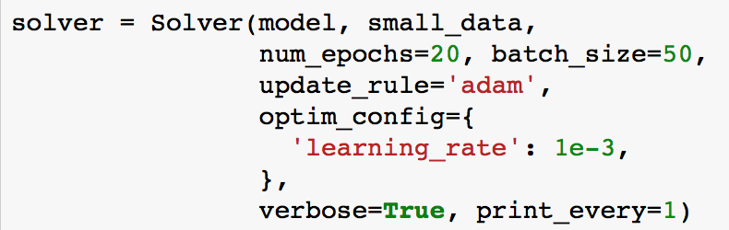

We get

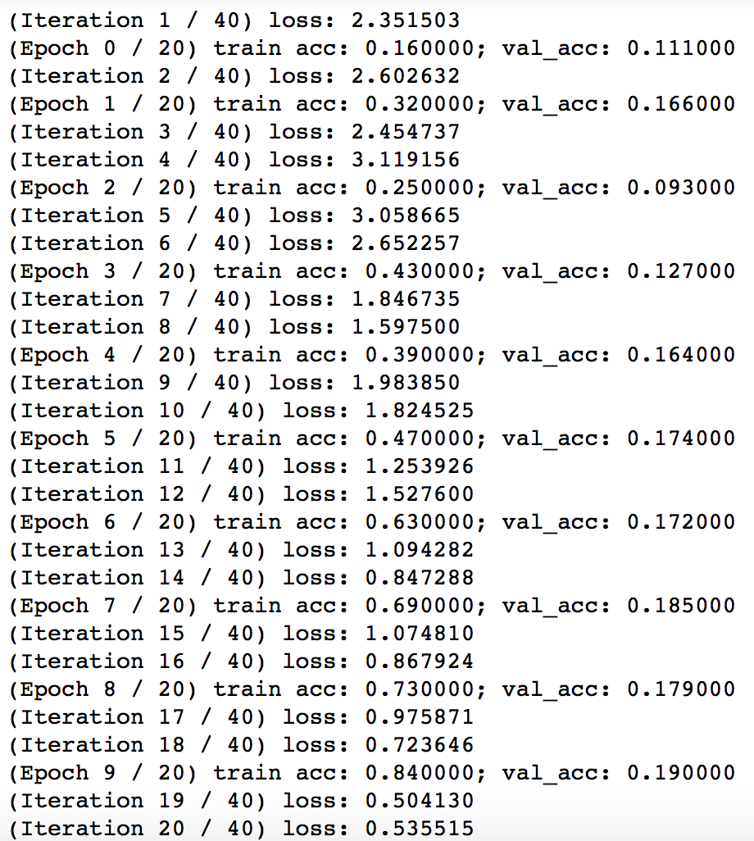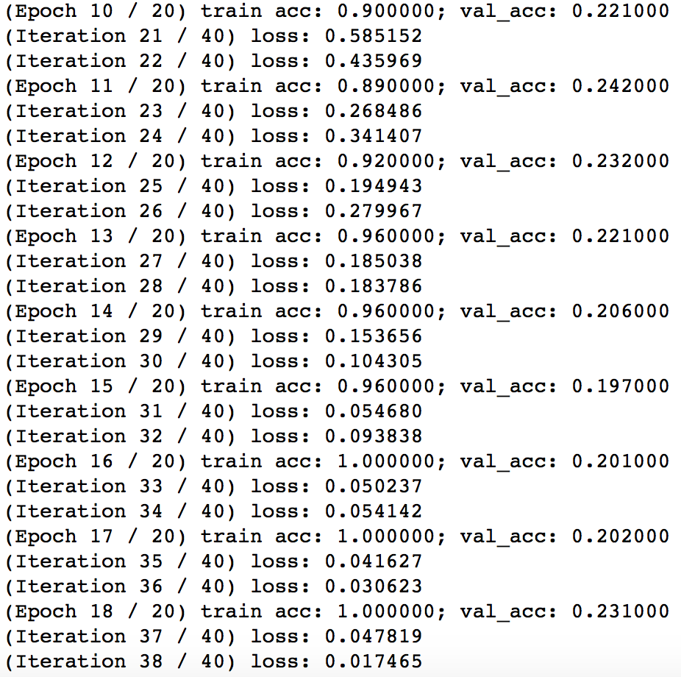

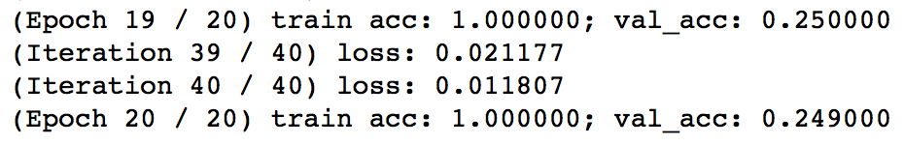

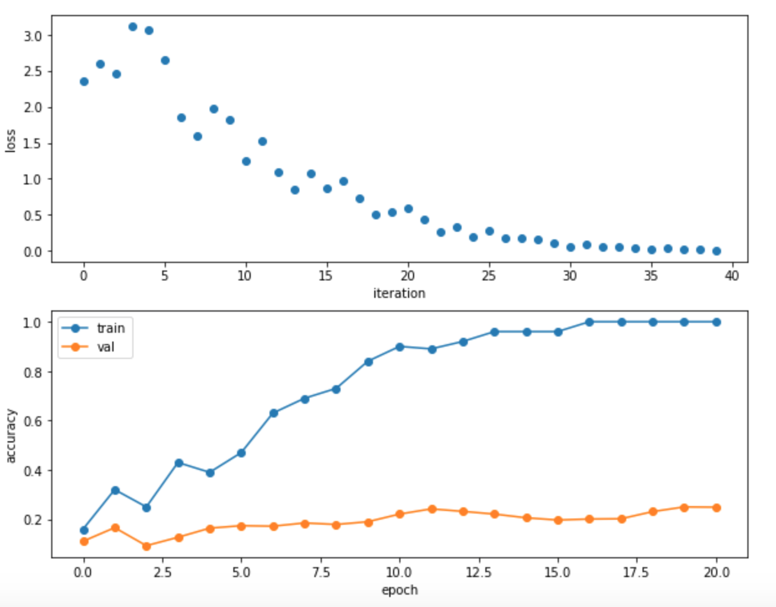

Problem 4.4.6: Train the CNN on the CIFAR-10 data

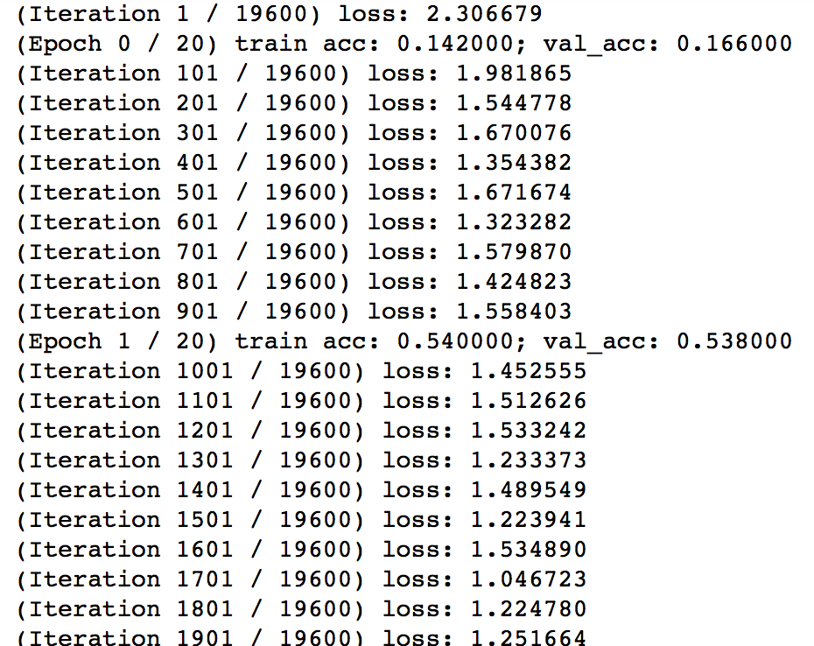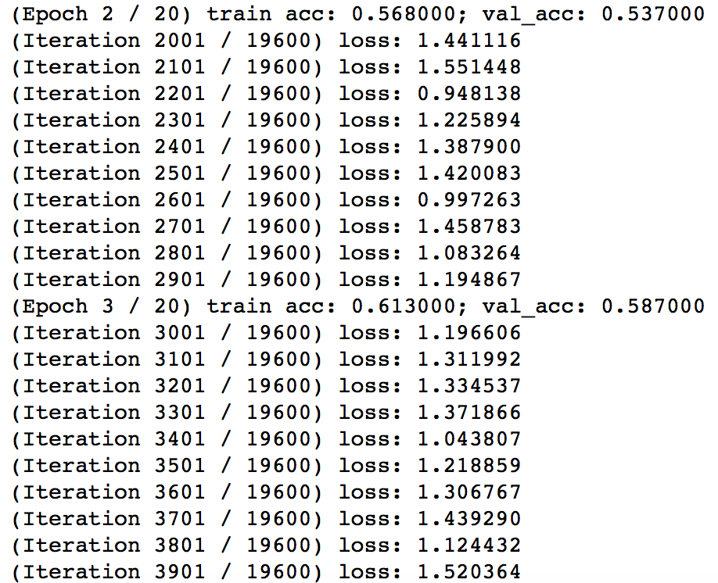

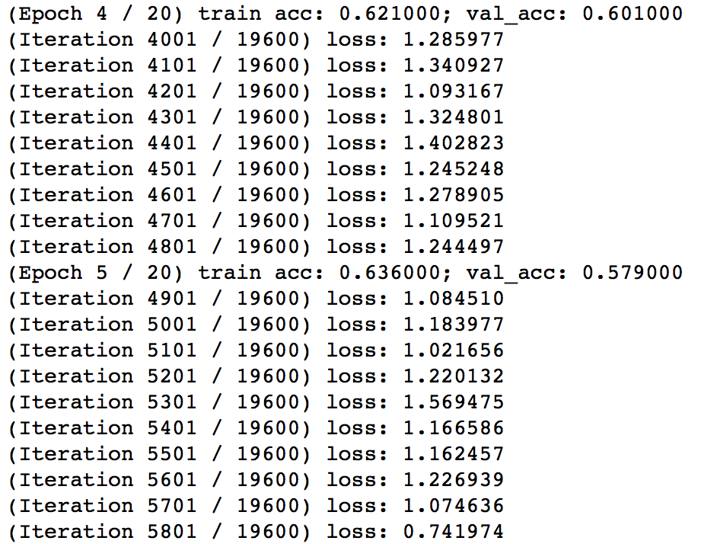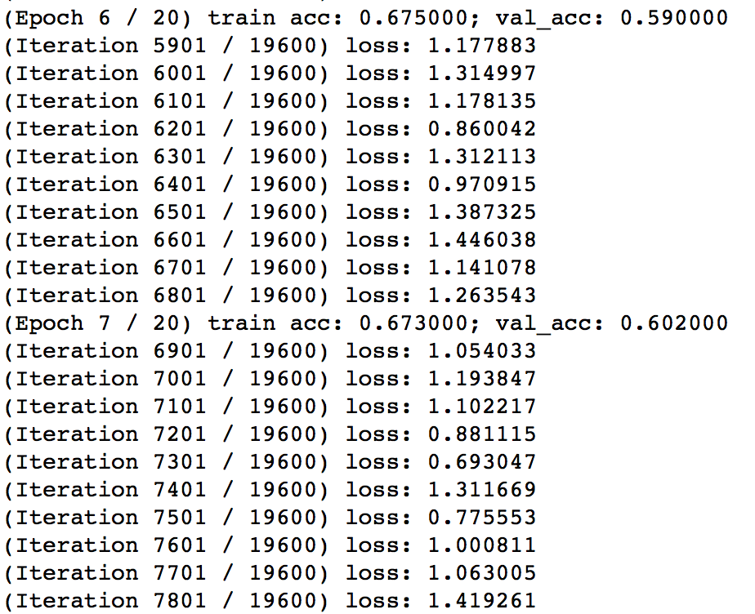

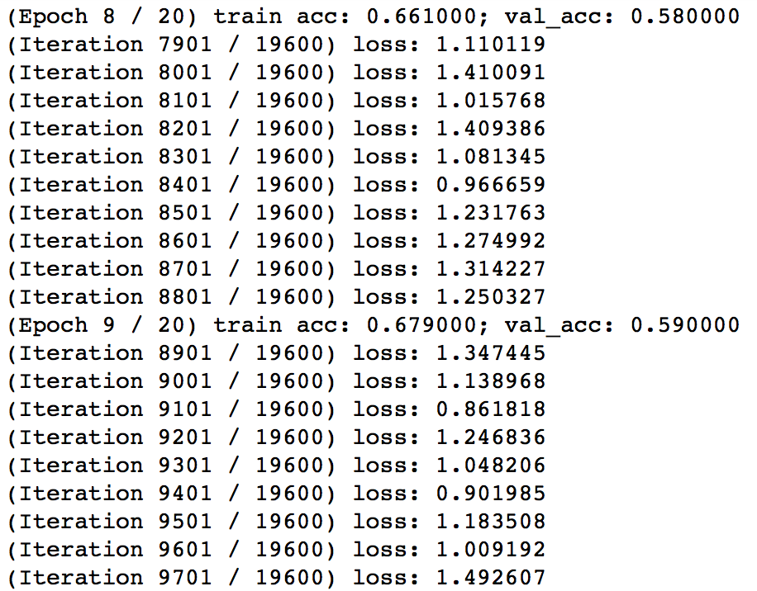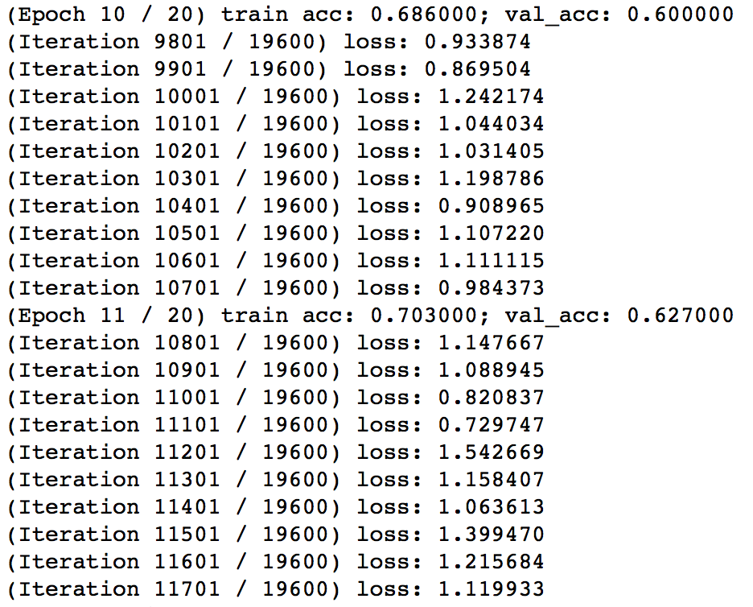

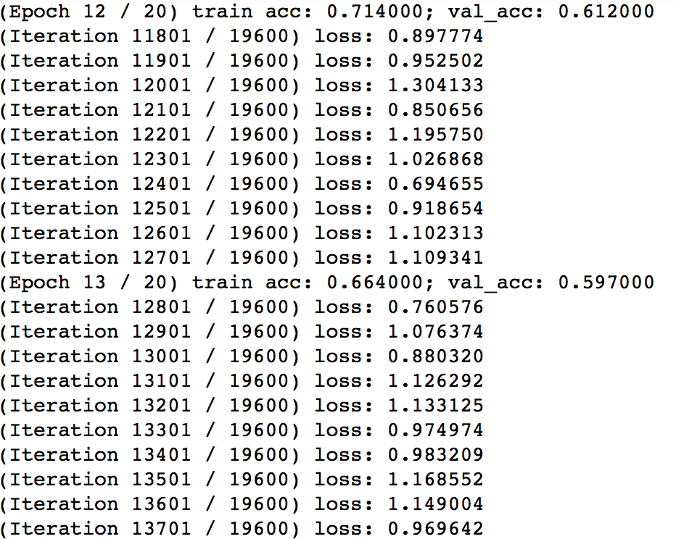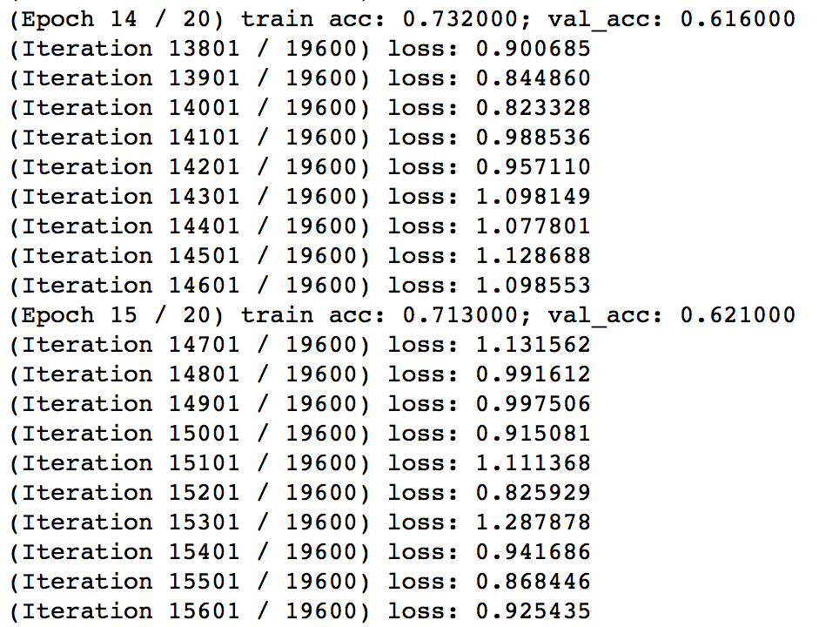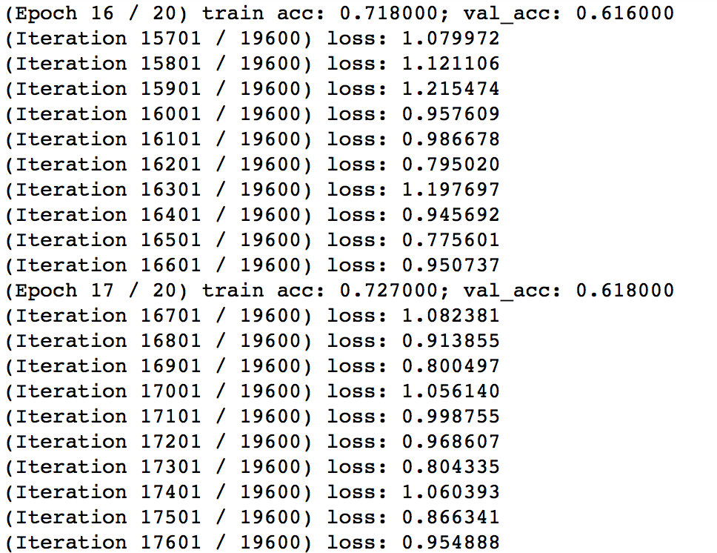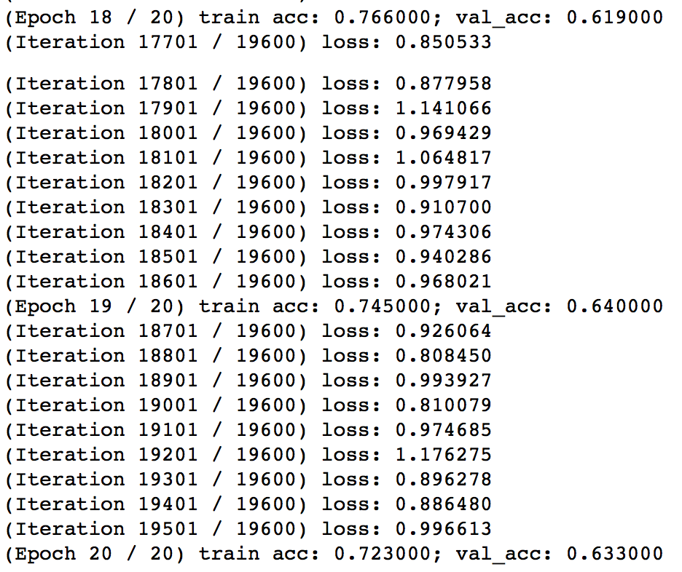

Extra credit: Problem 4.4.7: Train the best model for CIFAR-10 data